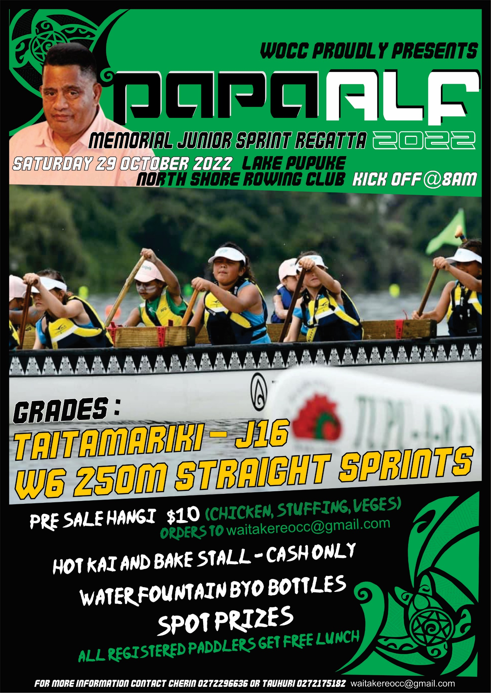

Papa Alf Memorial Junior Regatta 2022

He hōnore he kōroroia he maungarongo ki runga i te whenua he whakaaro pai ki ngā tāngata katoa.

Ka tangi ki ngā mate huhua o ngā tau, koutou kua huri tuara ki te pō, ki te murau a te tini ki te winirau a te mano.

Tīrama mai ki te poho o Ranginui hei wheturangi maumahara tīrama, pīata mai rā.

Ko rātou ki te rangi ko tātou ki te whenua tēna tātou katoa.

E mihi ana ki a koutou ngā tamariki, ngā whānau o ngā Karapu waka ama.

It has been a difficult time for all over the last 2 years. We hope you are well and safe.

The landscape has changed as we try to rebuild our juniors and our clubs. So we hope to keep this as stress free as possible. The Papa Alf Memorial race is not far away, so it’s a chance for our taitamariki to get together and have a bit of fun.

It's been a while so I hope we can pull off a awesome day for everyone and our region. There will be facepainting, goodie bags, prizes, free kai for paddlers.

There will also be Kai available for sale Hangi and food stalls.

Cost is $5 per paddler, just a reminder it’s a fun day so not protests!

So lets get our Tamariki out on the water.
Hikina te hoe!
Hoea!
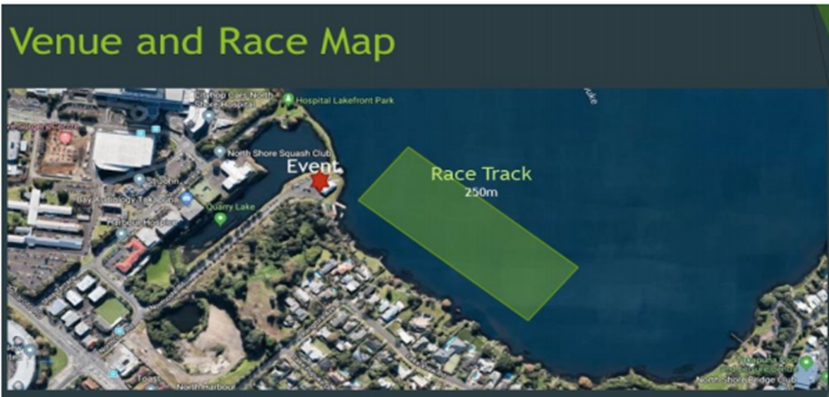

PROGRAMME
Saturday 29th October 2022
1A Northcote Road, Takapuna, Lake Pupuke, North Shore Rowing Club

RACES
W6 Taitamariki, Intermediate, and J16

EVENT SCHEDULE
7am: Check in - No registrations on the day.
7:45 am: Karakia
8:00am First race start
3:00pm Final race – subject to registrations

Race progression:
All races will be 250 sprint races.
• Heats
• Semis
• Finals
• Fun races subject to registrations
​
Basically 3 Races per Paddler with loads of experience to get ready, loading bay, paddle out and race!

● All waka must be Safety Checked
● All taitamariki and intermediate age divisions must wear life jackets

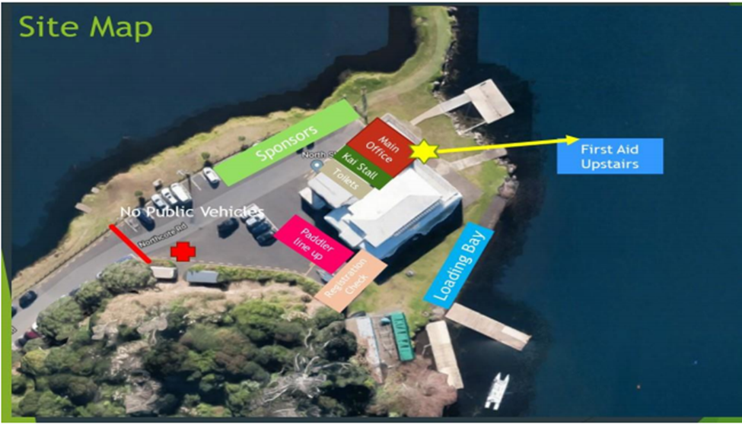
Venue, North Shore Rowing Club, Takapuna
1A Northcote Road, Takapuna, Lake Pupuke, North Shore Rowing Club
• Limited parking on site
• There will be food and Pre-sold Hangi available to be purchased
• Spot prizes available on the day

PLEASE REGISTER ON-LINE AT NKOA (WANZ) WEBSITE TO ENSURE ORGANISERS PROVIDE SUFFICIENT SUPPORT VESSELS.

Entry Fee: $5 per paddler

Entries Close: Tuesday 25th October 11.59pm
Rosters Close: Wednesday 26th October 11.59pm

Payment must be paid in one amount per club and cleared by the 26th October 2022.

Waitakere OCC
38-9014-0384894-00

There will be NO registrations on the day.

Arohanui from us all at Waitākere Outrigger Canoe Club!
Please print and sign waiver form below.

EVENT WAIVER and AUTHORITY FORM
Alf Pukepuke Memorial EVENT 29/10/2022
Team: Club:
Category entered:
I declare that:
- My accepted entry will not be transferred to another entrant.
- In the event of any “act of God” conditions causing a cancellation of the event, my total entry fee is not transferable or refundable.
- I acknowledge that there are risks involved with Waka Ama and fully realise the dangers of participating in an event such as this and fully assume the risks associated with such participation and my wellbeing during the event.
- I understand and agree that situations may arise during the event, which may be beyond the immediate control of ofﬁcials or organisers, and I must continually participate in a manner that does not endanger either myself or others.
- Neither the organisers, the sponsors nor other parties associated with the event shall have any responsibility, ﬁnancial or otherwise, for any risk incident that might arise, whether or not by negligence, from any direct or indirect loss, injury or death that might be -sustained by me or any other party directly or indirectly associated with me, from my intended or actual participation in the event or its related activities.
- I authorise my name, voice, picture, and information on this entry form to be used without payment to me in any broadcast, telecast, promotion, advertising, or any other way pursuant to the Privacy Act 1993.
- I agree to comply with the rules, regulations, and event instructions of the WAITAKERE OUTRIGGER CANOE CLUB.
- I consent to receiving medical treatment which may be advisable in the event of illness or injuries suffered during the event.
- I acknowledge and agree that I will always wear a PFD while on the water.
If Competitor is under 18 the Waiver must be signed by Parent or guardian. Please ✓ if so.
Paddlers full name | Date of Birth | NKOA Member ✓ | Medical Conditions  (“No” or specify) | Sign  (✓ if parent / guardian)

